The java.util.Arrays class provides a collection of static methods for manipulating arrays, including sorting, searching, and comparing.
Sort

1. sort(array)
- Description: Sorts the entire array in ascending order.
- Overloaded for:
  - All primitive types (int[], double[], char[], etc.)
  - Object arrays (using natural ordering or a comparator).
- Return Type: void (it modifies the array in place).
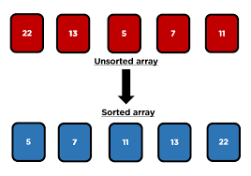
Example:
import java.util.Arrays;

public class SortExample {
public static void main(String[] args) {
int[] numbers = {5, 3, 8, 1, 2};
Arrays.sort(numbers); // Sorts entire array

System.out.println(Arrays.toString(numbers));
}
}
Output:
[1, 2, 3, 5, 8]

2. sort(array, fromIndex, toIndex)
- Description: Sorts a specified range of the array.
- Range: From fromIndex (inclusive) to toIndex (exclusive).
- Return Type: void.
Example:
import java.util.Arrays;

public class RangeSortExample {
public static void main(String[] args) {
int[] numbers = {9, 7, 5, 3, 1};
Arrays.sort(numbers, 1, 4); // Sorts elements from index 1 to 3

System.out.println(Arrays.toString(numbers));
}
}
Output:
[9, 3, 5, 7, 1]

3. parallelSort(array)
- Description: Sorts the entire array in parallel using multiple threads.
- Use Case: Faster on large arrays compared to normal sort().
- Return Type: void.
Example:
import java.util.Arrays;

public class ParallelSortExample {
public static void main(String[] args) {
int[] numbers = {20, 15, 30, 5, 10};
Arrays.parallelSort(numbers); // Parallel sorting

System.out.println(Arrays.toString(numbers));
}
}
Output:
[5, 10, 15, 20, 30]

4. parallelSort(array, fromIndex, toIndex)
- Description: Sorts a subarray in parallel.
- Range: From fromIndex (inclusive) to toIndex (exclusive).
- Return Type: void.
Example:
import java.util.Arrays;

public class ParallelRangeSortExample {
public static void main(String[] args) {
int[] numbers = {50, 40, 30, 20, 10};
Arrays.parallelSort(numbers, 1, 4); // Sort elements from index 1 to 3 in parallel

System.out.println(Arrays.toString(numbers));
}
}
Output:
[50, 20, 30, 40, 10]

Difference between sort() and parallelSort():
- sort() → Single-threaded, stable sorting.
- parallelSort() → Multi-threaded, faster for large arrays, but overhead may make it slower for small arrays.

binarySearch

1. 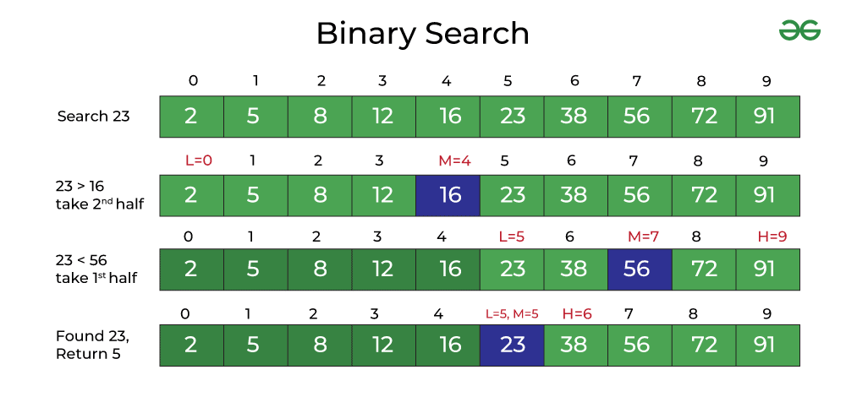

binarySearch(array, key)
- Description:
Searches for a key in the entire sorted array using the binary search algorithm.
- Precondition: The array must be sorted in ascending order, otherwise the result is unpredictable.
- Return Type: int
  - If the key is found → returns the index of the key.
  - If the key is not found → returns -(insertion_point) - 1.
Example:
import java.util.Arrays;

public class BinarySearchExample1 {
public static void main(String[] args) {
int[] numbers = {10, 20, 30, 40, 50};
int index1 = Arrays.binarySearch(numbers, 30); // key found
int index2 = Arrays.binarySearch(numbers, 25); // key not found

System.out.println("Index of 30: " + index1);
System.out.println("Index of 25: " + index2);
}
}
Output:
Index of 30: 2
Index of 25: -3
Here, -3 means if 25 were inserted, it would be at index 2 (between 20 and 30).

2. binarySearch(array, fromIndex, toIndex, key)
- Description:
Searches a subarray (range) of the sorted array for the key.
- Range: From fromIndex (inclusive) to toIndex (exclusive).
- Return Type: int (same rules as above).
Example:
import java.util.Arrays;

public class BinarySearchExample2 {
public static void main(String[] args) {
int[] numbers = {5, 15, 25, 35, 45, 55};
int index1 = Arrays.binarySearch(numbers, 1, 4, 25); // within range
int index2 = Arrays.binarySearch(numbers, 1, 4, 45); // outside range

System.out.println("Index of 25 in range: " + index1);
System.out.println("Index of 45 in range: " + index2);
}
}
Output:
Index of 25 in range: 2
Index of 45 in range: -4
Notice: 45 exists in the array, but since it’s outside the given range (1–3), it returns -(insertion_point) - 1.

3. binarySearch(array, key, Comparator)
- Description:
Searches a sorted Object array using a custom Comparator for ordering.
- Precondition: Array must be sorted with the same comparator.
- Return Type: int (index if found, otherwise negative insertion point).
Example:
import java.util.Arrays;
import java.util.Comparator;

public class BinarySearchExample3 {
public static void main(String[] args) {
String[] names = {"Amit", "Rahul", "Vijay", "Suresh"};
Arrays.sort(names, Comparator.reverseOrder()); // sort in descending order

int index1 = Arrays.binarySearch(names, "Vijay", Comparator.reverseOrder());
int index2 = Arrays.binarySearch(names, "Deepak", Comparator.reverseOrder());

System.out.println("Index of Vijay: " + index1);
System.out.println("Index of Deepak: " + index2);
}
}
Output:
Index of Vijay: 1
Index of Deepak: -4

⚖️ Summary Table
Method | Description | Return Type | Notes
binarySearch(array, key) | Searches entire sorted array for a key | int | Requires ascending sorted array
binarySearch(array, fromIndex, toIndex, key) | Searches a specified range for a key | int | Only considers elements in [fromIndex, toIndex)
binarySearch(array, key, Comparator) | Searches Object array using custom comparator | int | Array must be sorted with same comparator

Arrays.equals() & Arrays.deepEquals()
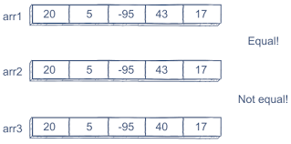

1. equals(array1, array2)
- Description:
Compares two arrays element by element.
- Works for: All primitive and Object arrays.
- Return Type: boolean
  - true → if both arrays have the same length and all elements are equal in the same order.
  - false → otherwise.
Example:
import java.util.Arrays;

public class EqualsExample {
public static void main(String[] args) {
int[] arr1 = {1, 2, 3};
int[] arr2 = {1, 2, 3};
int[] arr3 = {1, 3, 2};

System.out.println(Arrays.equals(arr1, arr2)); // true
System.out.println(Arrays.equals(arr1, arr3)); // false
}
}
Output:
true
false

2. deepEquals(array1, array2)
- Description:
Compares two multidimensional arrays for equality.
- Why needed?
  - equals() does not check nested arrays properly (it compares references, not contents).
  - deepEquals() checks contents recursively inside subarrays.
- Return Type: boolean.
Example:
import java.util.Arrays;

public class DeepEqualsExample {
public static void main(String[] args) {
int[][] arr1 = {{1, 2}, {3, 4}};
int[][] arr2 = {{1, 2}, {3, 4}};
int[][] arr3 = {{1, 4}, {3, 2}};

System.out.println(Arrays.equals(arr1, arr2)); // false (compares references)
System.out.println(Arrays.deepEquals(arr1, arr2)); // true (compares values deeply)
System.out.println(Arrays.deepEquals(arr1, arr3)); // false
}
}

Output:
false
true
false

Summary Table
Method | Description | Works On | Return Type | Special Note
equals(array1, array2) | Compares two arrays element-wise | Primitive & Object arrays | boolean | Only 1D comparison
deepEquals(array1, array2) | Compares two arrays recursively (deep comparison) | Multi-dimensional arrays | boolean | Use for 2D/3D arrays

Arrays.fill() Methods
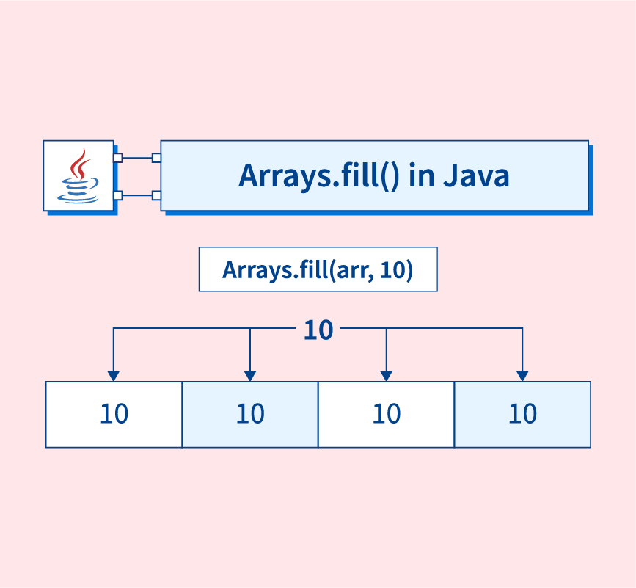

1. fill(array, value)
- Description:
Fills the entire array with the given value.
- Works for: All primitive arrays (int[], double[], etc.) and Object arrays.
- Return Type: void (modifies array in place).
Example:
import java.util.Arrays;

public class FillExample1 {
public static void main(String[] args) {
int[] arr = new int[5];
Arrays.fill(arr, 7); // Fill all elements with 7

System.out.println(Arrays.toString(arr));
}
}
Output:
[7, 7, 7, 7, 7]

2. fill(array, fromIndex, toIndex, value)
- Description:
Fills a specified range of the array with the given value.
- Range: From fromIndex (inclusive) to toIndex (exclusive).
- Return Type: void.
Example:
import java.util.Arrays;

public class FillExample2 {
public static void main(String[] args) {
int[] arr = {1, 2, 3, 4, 5};
Arrays.fill(arr, 1, 4, 9); // Fill elements from index 1 to 3 with 9

System.out.println(Arrays.toString(arr));
}
}
Output:
[1, 9, 9, 9, 5]

Summary Table
Method | Description | Range | Return Type | Example
fill(array, value) | Fills the entire array with the specified value | Whole array | void | Arrays.fill(arr, 7);
fill(array, fromIndex, toIndex, value) | Fills a subarray with the specified value | [fromIndex, toIndex) | void | Arrays.fill(arr, 1, 4, 9);

Arrays.copyOf() and Arrays.copyOfRange()
  - 1. copyOf(originalArray, newLength)
- Description:
Creates a new array by copying elements from the original array.
  - If newLength < original length → array is truncated.
  - If newLength > original length → array is padded with default values (0, false, null, etc.).
- Return Type: A new array of the same type.
Example:
import java.util.Arrays;

public class CopyOfExample {
public static void main(String[] args) {
int[] arr = {10, 20, 30, 40};

int[] copy1 = Arrays.copyOf(arr, 2); // Truncate
int[] copy2 = Arrays.copyOf(arr, 6); // Extend with default values

System.out.println("Truncated copy: " + Arrays.toString(copy1));
System.out.println("Extended copy: " + Arrays.toString(copy2));
}
}
Output:
Truncated copy: [10, 20]
Extended copy: [10, 20, 30, 40, 0, 0]

  - 2. copyOfRange(originalArray, from, to)
- Description:
Copies a specified range (from inclusive, to exclusive) into a new array.
- Range: [from, to) (like substring() in Strings).
- Return Type: A new array of the same type.
Example:
import java.util.Arrays;

public class CopyOfRangeExample {
public static void main(String[] args) {
int[] arr = {5, 10, 15, 20, 25};

int[] subArray1 = Arrays.copyOfRange(arr, 1, 4); // 10, 15, 20
int[] subArray2 = Arrays.copyOfRange(arr, 3, 7); // extends with default values

System.out.println("Subarray 1: " + Arrays.toString(subArray1));
System.out.println("Subarray 2: " + Arrays.toString(subArray2));
}
}
Output:
Subarray 1: [10, 15, 20]
Subarray 2: [20, 25, 0, 0]

Important Arrays Class Utility Methods (Part 2)

  - 1. asList(array)
- Description: Returns a fixed-size List backed by the specified array (changes in the array reflect in the list and vice versa).
- Return Type: List<T>
Example:
import java.util.*;

public class AsListExample {
public static void main(String[] args) {
String[] arr = {"A", "B", "C"};
List<String> list = Arrays.asList(arr);

System.out.println(list);

arr[1] = "Z"; // Change in array reflects in list
System.out.println(list);
}
}
Output:
[A, B, C]
[A, Z, C]
Note: The returned list is fixed-size → you cannot add/remove elements.

  - 2. toString(array)
- Description: Returns a string representation of a one-dimensional array.
- Return Type: String
Example:
int[] arr = {10, 20, 30};
System.out.println(Arrays.toString(arr));
Output:
[10, 20, 30]

  - 3. deepToString(array)
- Description: Returns a string representation of a multi-dimensional array.
- Return Type: String
Example:
int[][] arr = {{1, 2}, {3, 4}};
System.out.println(Arrays.deepToString(arr));
Output:
[[1, 2], [3, 4]]

  - 4. hashCode(array)
- Description: Returns a hash code based on the contents of a one-dimensional array.
- Return Type: int
Example:
int[] arr = {1, 2, 3};
System.out.println(Arrays.hashCode(arr));
Output (example):
30817

  - 5. deepHashCode(array)
- Description: Returns a hash code based on the deep contents of a multi-dimensional array.
- Return Type: int
Example:
int[][] arr = {{1, 2}, {3, 4}};
System.out.println(Arrays.deepHashCode(arr));
Output (example):
30817

  - 6. compare(array1, array2)
- Description: Compares two arrays lexicographically.
- Return Type: int
  - 0 → if arrays are equal
  - <0 → if first array < second
  - >0 → if first array > second
Example:
int[] a = {1, 2, 3};
int[] b = {1, 2, 4};

System.out.println(Arrays.compare(a, b));
Output:
-1

  - 7. mismatch(array1, array2)
- Description: Finds the index of the first mismatch between two arrays.
- Return Type: int
  - Index of mismatch
  - -1 if arrays are identical
Example:
int[] a = {10, 20, 30};
int[] b = {10, 25, 30};

System.out.println(Arrays.mismatch(a, b));
Output:
1

  - 8. stream(array)
- Description: Returns a Stream from an array.
- Return Type: Stream<T> or primitive streams (IntStream, LongStream, etc.).
Example:
import java.util.Arrays;

public class StreamExample {
public static void main(String[] args) {
int[] arr = {1, 2, 3, 4};
Arrays.stream(arr).forEach(System.out::println);
}
}
Output:
1
2
3
4

  - 9. setAll(array, generator)
- Description: Sets all elements of an array using a generator function (index → value).
- Return Type: void.
Example:
import java.util.Arrays;

public class SetAllExample {
public static void main(String[] args) {
int[] arr = new int[5];
Arrays.setAll(arr, i -> i * i); // fill with squares of index

System.out.println(Arrays.toString(arr));
}
}
Output:
[0, 1, 4, 9, 16]

  - 10. parallelSetAll(array, generator)
- Description: Same as setAll, but parallelized for performance on large arrays.
- Return Type: void.
Example:
import java.util.Arrays;

public class ParallelSetAllExample {
public static void main(String[] args) {
int[] arr = new int[5];
Arrays.parallelSetAll(arr, i -> i + 100);

System.out.println(Arrays.toString(arr));
}
}
Output:
[100, 101, 102, 103, 104]

Final Summary Table
Method | Description | Return Type
asList(array) | Fixed-size List backed by array | List<T>
toString(array) | String representation of 1D array | String
deepToString(array) | String representation of multi-D array | String
hashCode(array) | Hash code based on 1D array | int
deepHashCode(array) | Hash code based on deep contents | int
compare(a1, a2) | Lexicographic comparison of arrays | int
mismatch(a1, a2) | First mismatch index | int
stream(array) | Stream from array | Stream / IntStream
setAll(array, gen) | Fill array using generator | void
parallelSetAll(array, gen) | Parallel fill with generator | void

